**Error / Bug for Puja Permission**

* In respect of Block or Municipality, the dropdown for block or municipality should hide or show.
* There should be validation for date as immersion date cannot be less than start date.

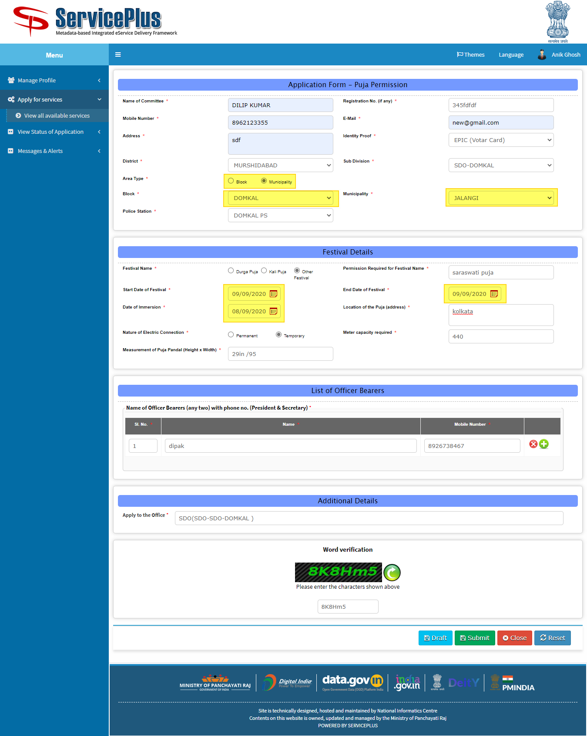

After Submitting the application is not going to Fire Brigade officer rather it’s going to WBSEDCL for approval.

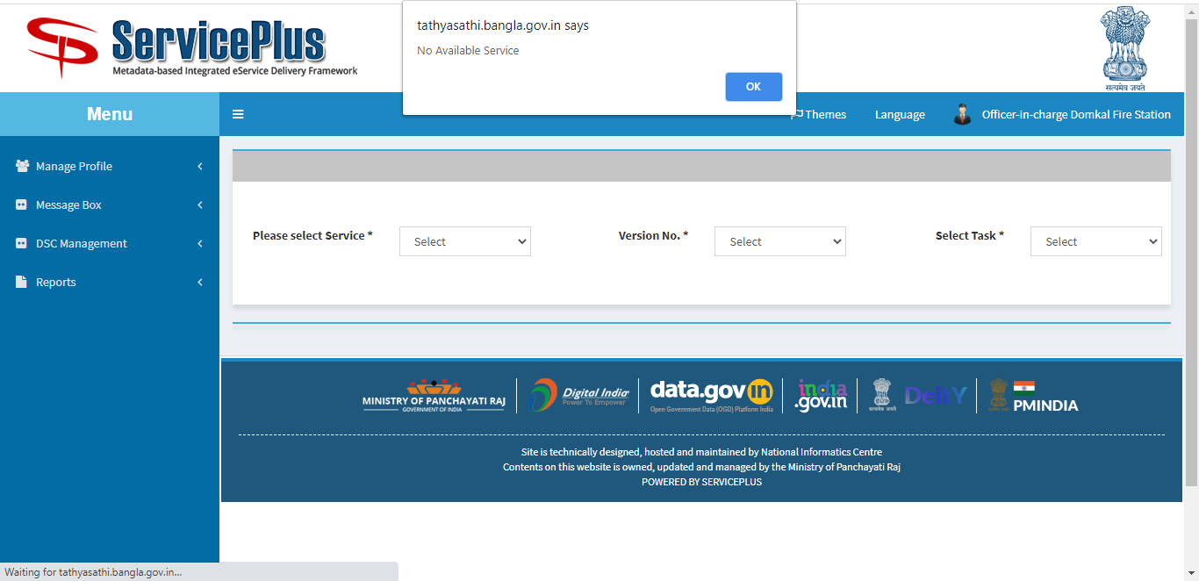

Here WBSEDCL is forwarding to fire brigade but as per document it should have passed to police station.

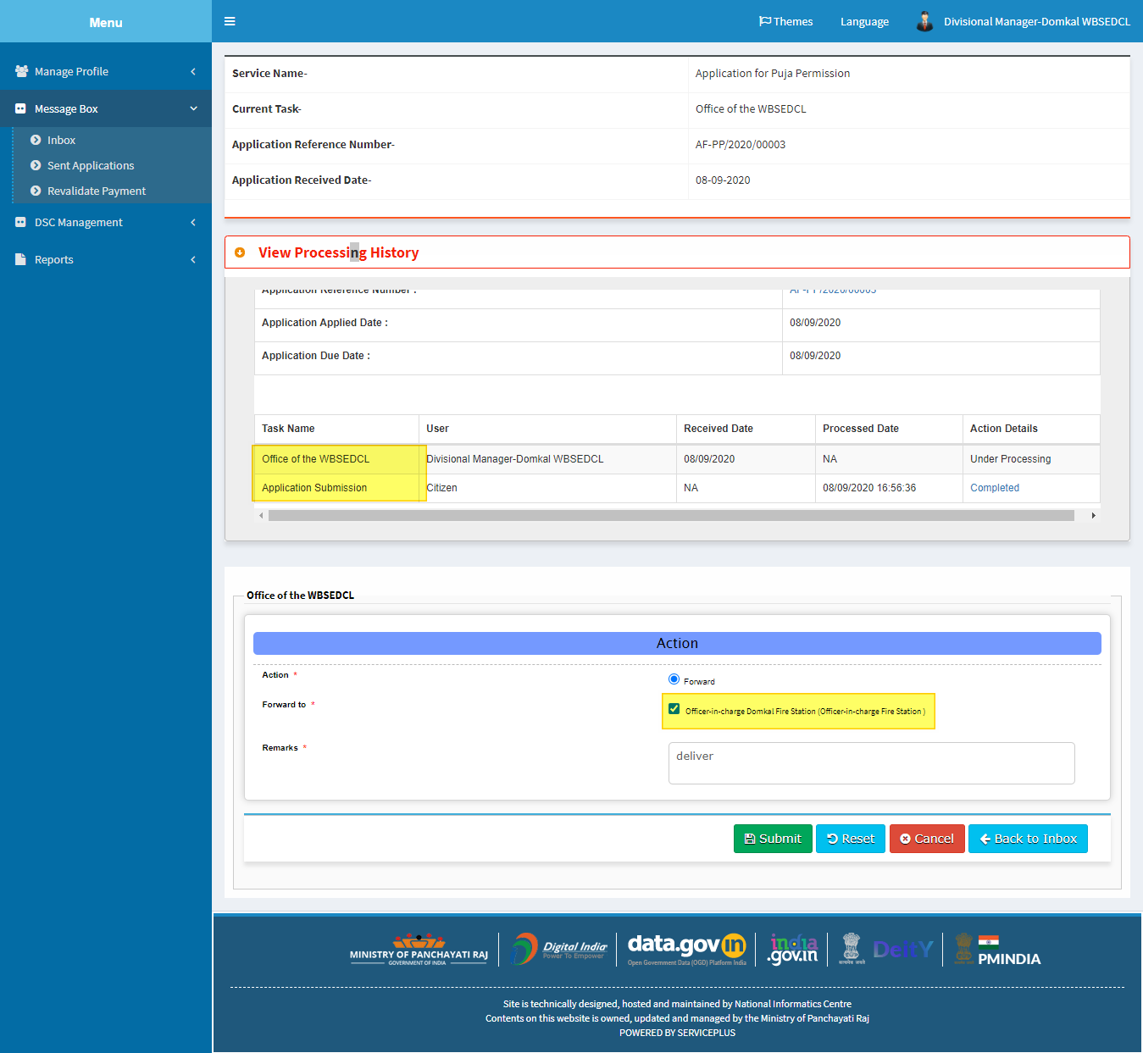

Here all PS is showing for forwarding.

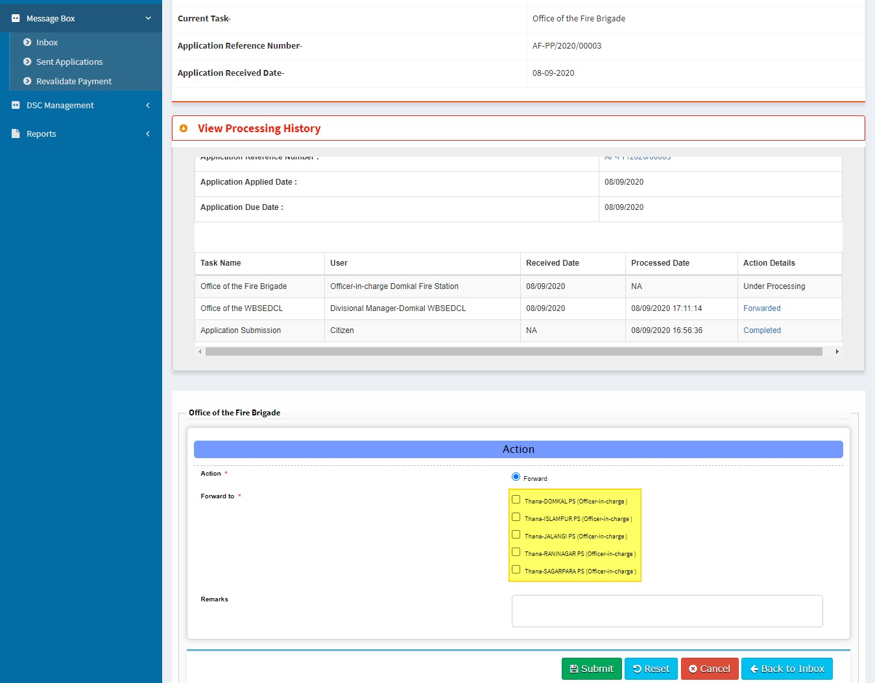

No local

Not show remarks ( Access Denied) which action form process by SDPO.

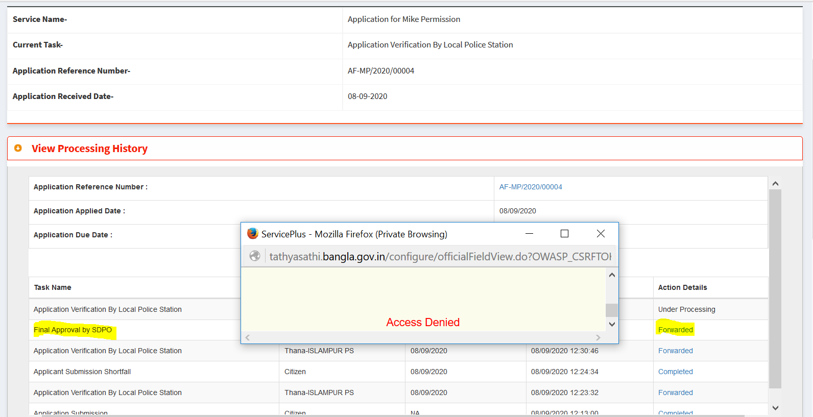

Yellow mark hide on load page.

If checked on forward then show yellow mark.

Otherwise always hide.

“User” change to “Forward to” or “Recommend to”

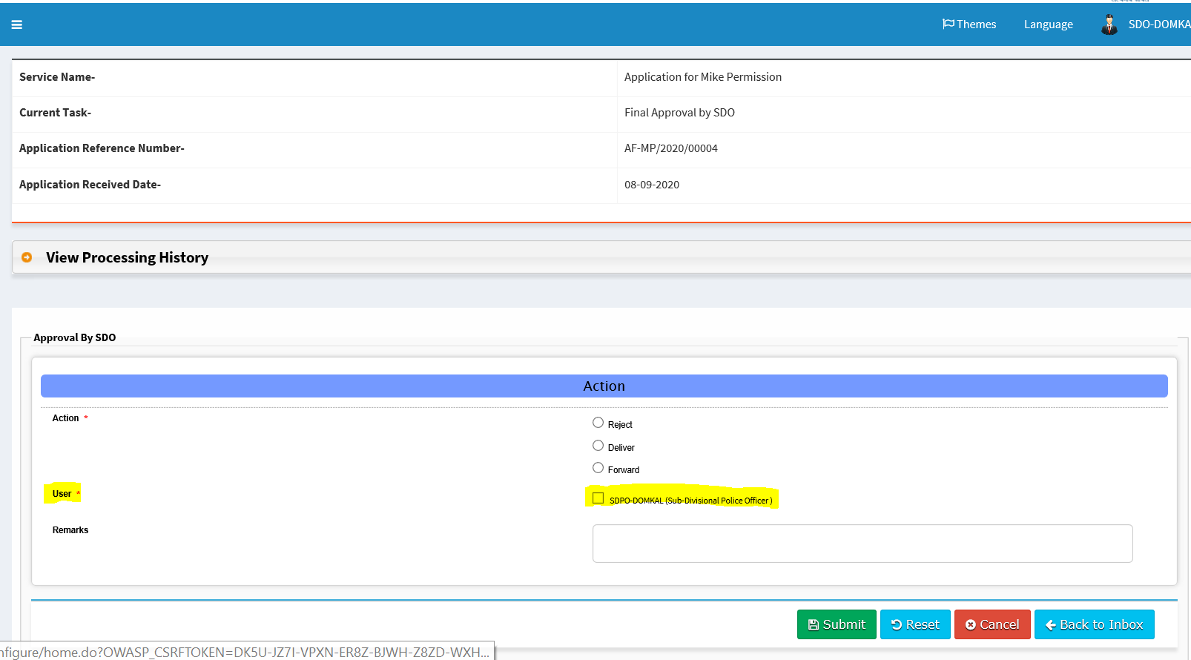

Documents issue:-

1. Give space after Subject line
2. All line justified.
3. Selected Concerned BDO
4. Selected concerned Thana.

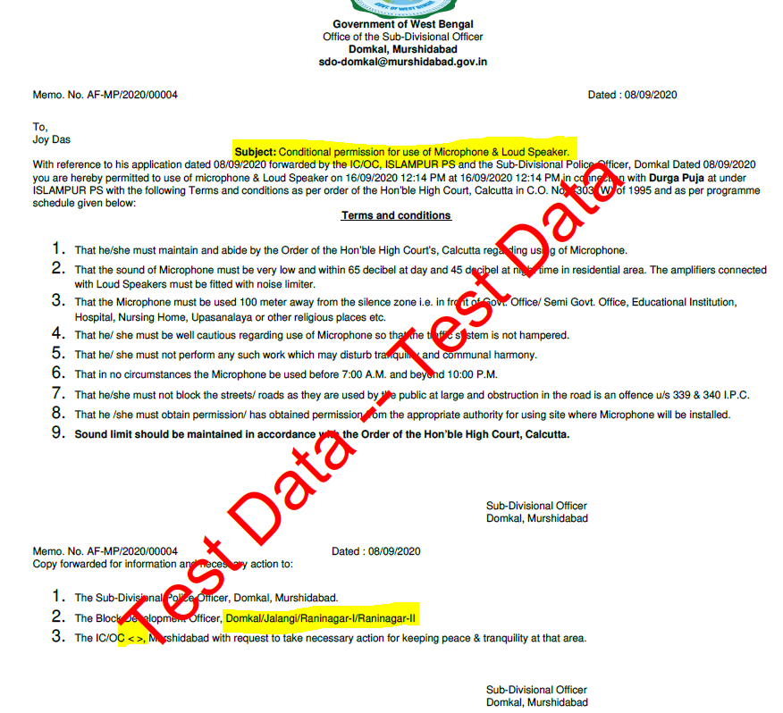

*** Not working alert of email notification.